**OTHER PAGES TEMPLATES**

1. **Templates for Dogs, Cats, Birds and Small Pets –**

All these 4 pages will be similar with image at top and categories of products at left and then the products according to those categories at the right (cards style).

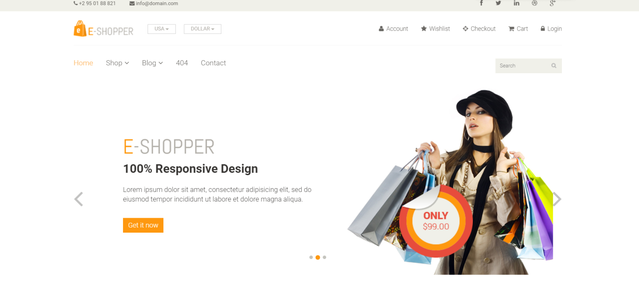

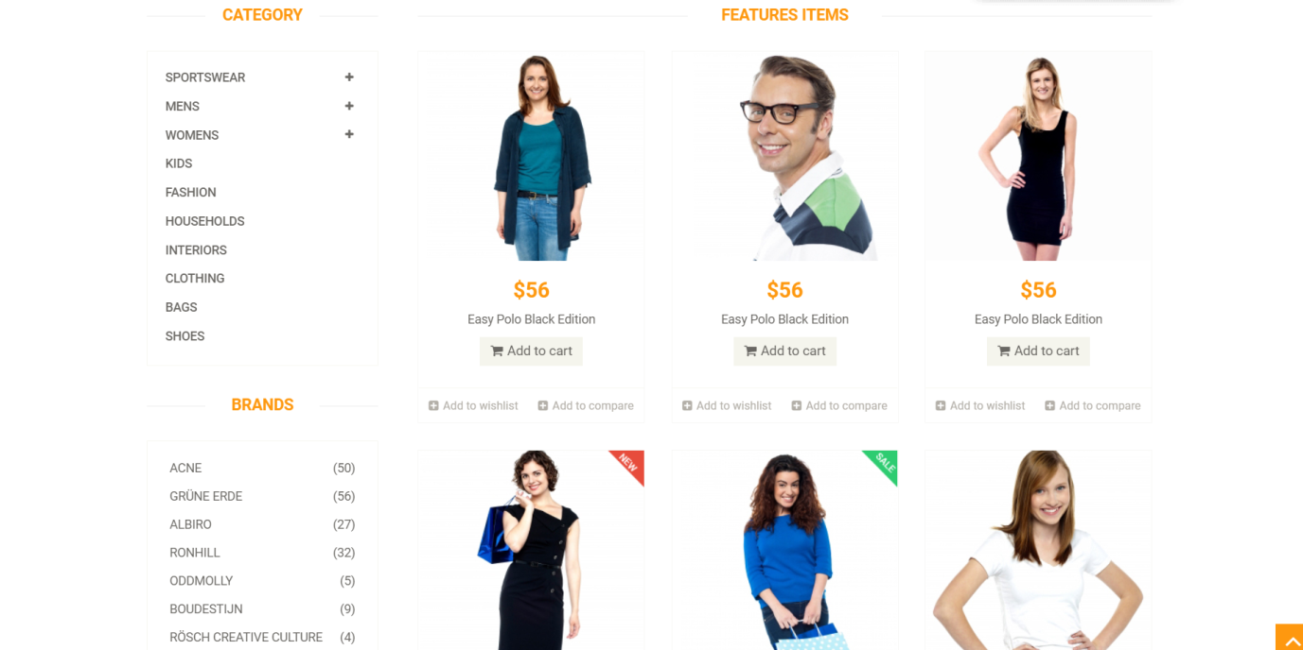

Link to template - <https://www.free-css.com/free-css-templates/page203/e-shopper>

1. **Brands –**

Brands page will also have design similar to above design with all brand names at the left and products displayed according to brands on the right.

1. **On Sale –**

The on sale page will consists of images and on hover will show the add to cart option. All the images will be displayed according to below fasion.

They can also be displayed according to categories like dogs/ cats/ birds/small pets by clickinh on the buttons at the top of images (here- ALL APP CARD WEB).

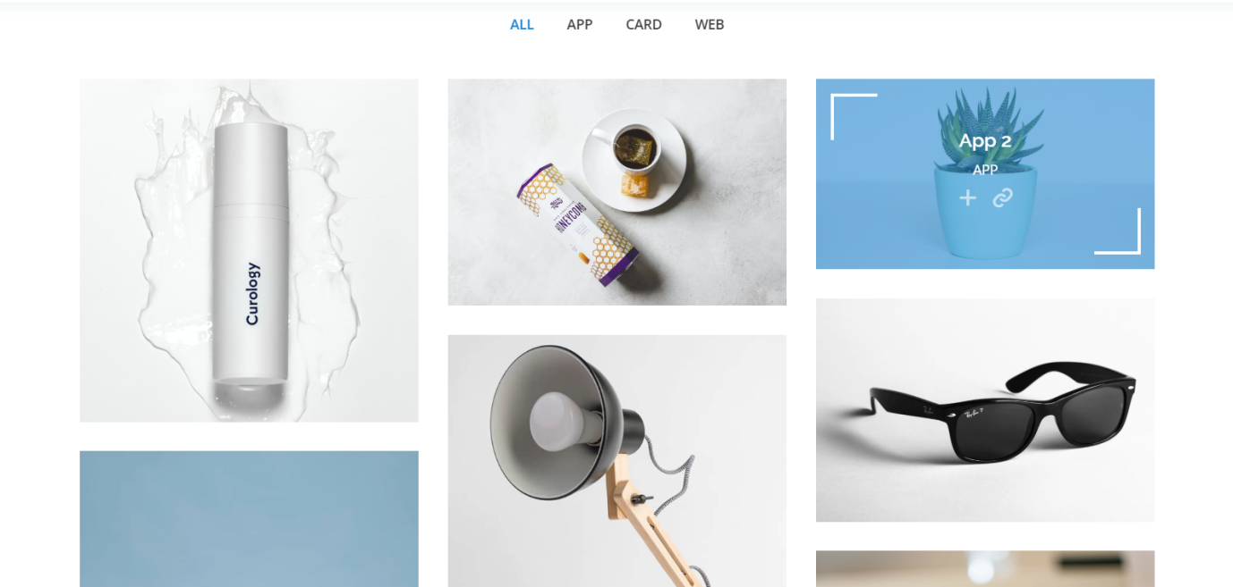

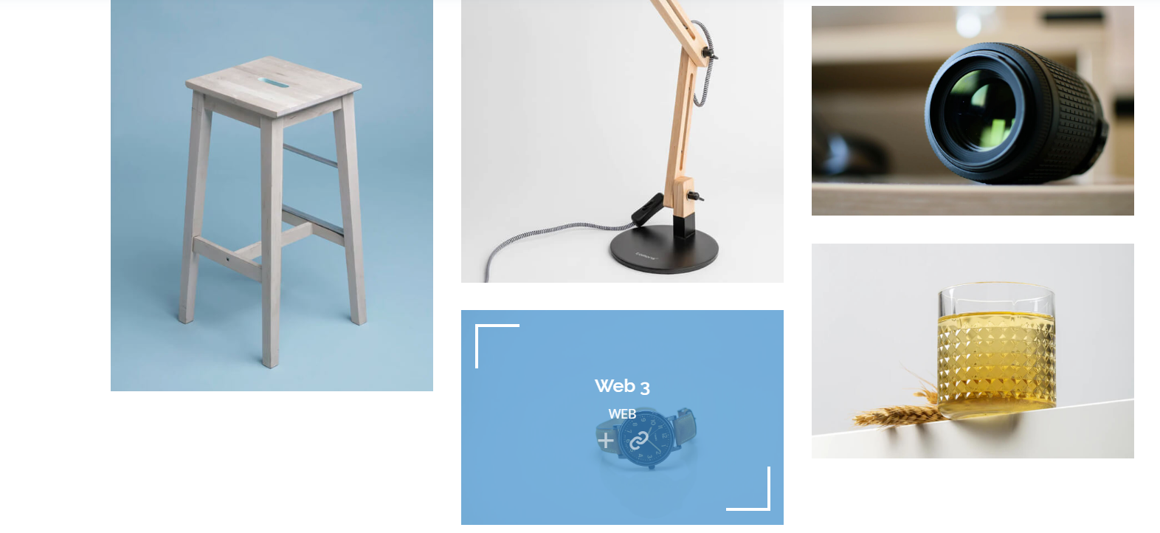

Link to the Template - <https://bootstrapmade.com/demo/OnePage/> (refer portfolio section)

1. **Blog/ About Us –**

If required.

**On Sale –**

Other example templates for on sale –

Links for Templates **-** <https://www.free-css.com/free-css-templates/page254/rd-business>

<https://bootstrapmade.com/demo/Amoeba/>



